0 to Million Users
Let suppose we need to make an application for large number of users for scaling in this documentation we will learn how we can design the architecture of system design start from 0 to Million users setup.

Step by Step procedure :-
- Setup a single server.
- Separate Application and Database server.
- Add load balancer and multiple app servers.
- Apply database replication.
- Apply caching
- Apply CDN-(Content Delivery Network).
- Data Center.
- Use Messaging Queue.
- Database Scaling.

- Single sever – This is very starting step we need one client and server. Client can directly connect with the server has both application and database initially.
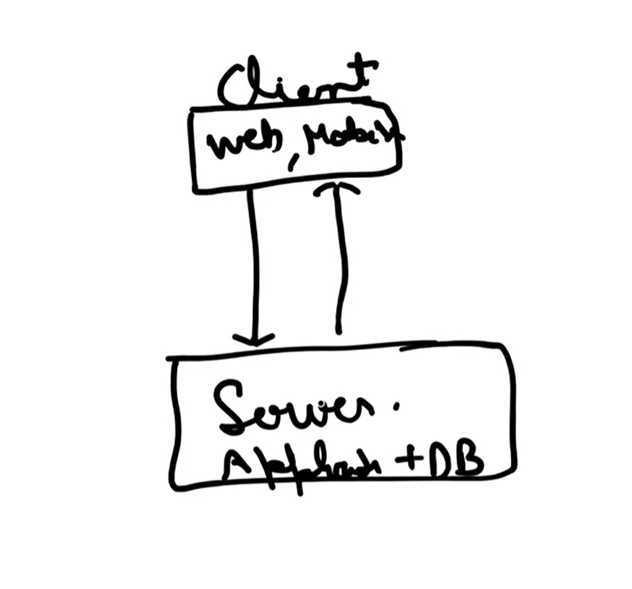
Server has database hosted inside it. Like we make the college projects.

- Separate Application and Database server – because lets suppose I have to grow application and database independently then this could be the better solution.
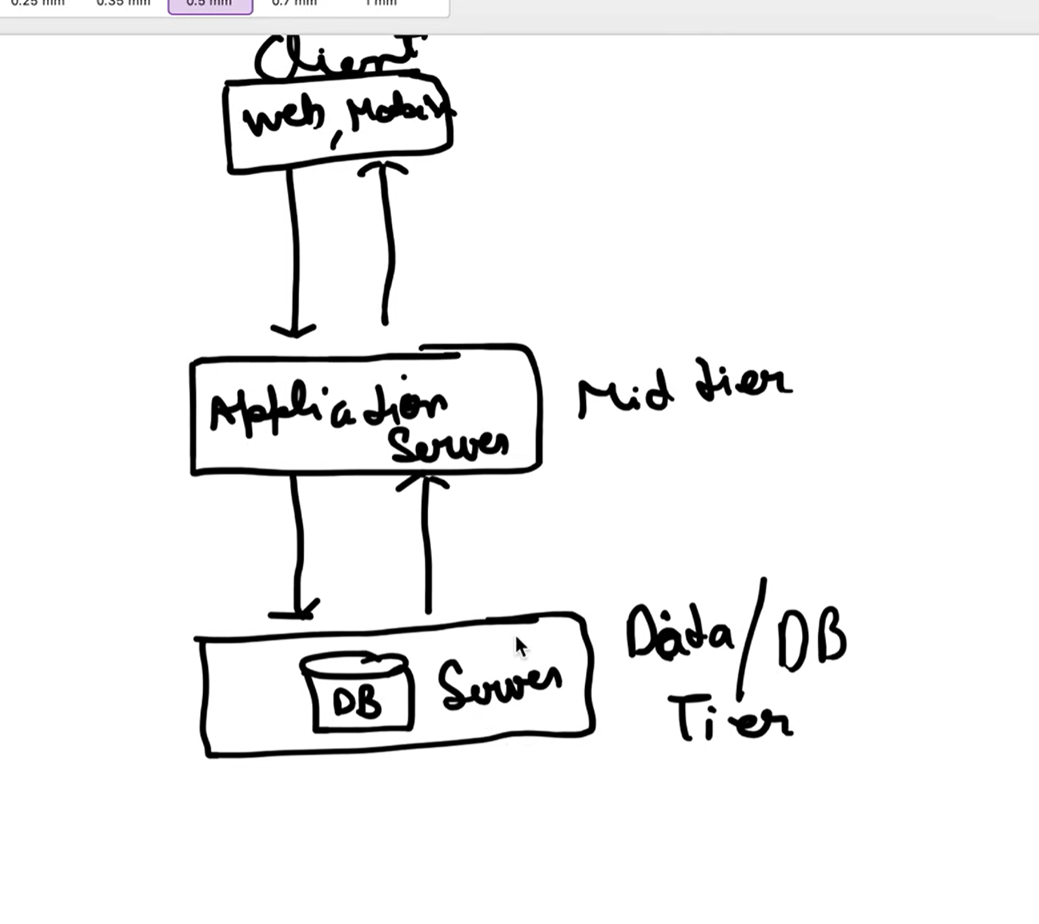
3. Add load balancer and multiple app servers – if I want more traffic then I need to add load balancer for handling traffic (e.g.- load balancer divides the traffic over different application servers) and separate app servers in multiple instances. Client will talk to load balancer and load balancer decides where to send the requests. Load balancer also provides the security eg:- load balancers talks with application on private ip’s.
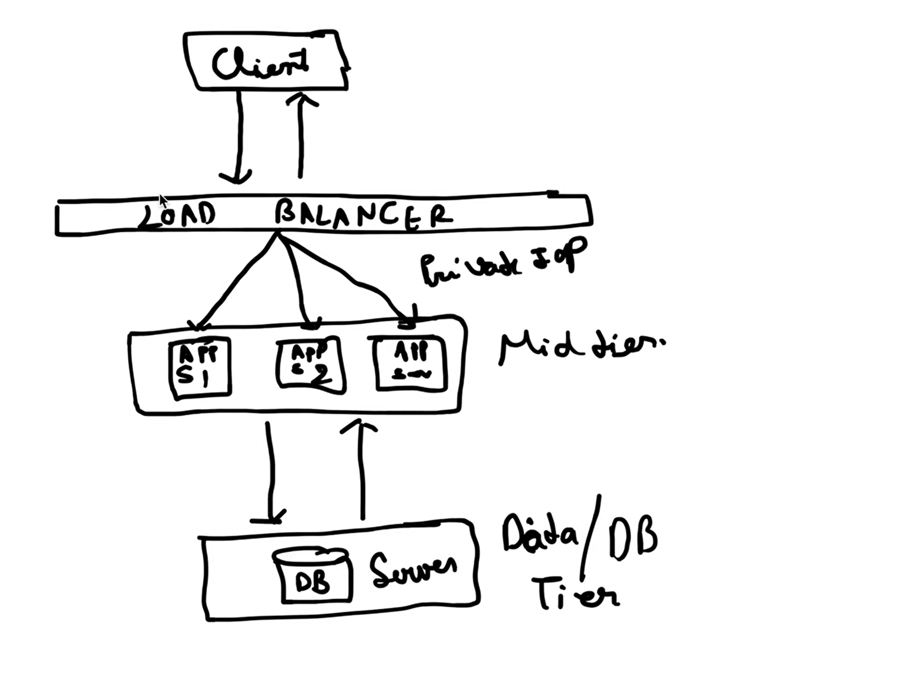
Why we need multiple app servers here because after a single app server has limit of request to accept let’s suppose server A has 1 lakh limit, after one lakh limit load balancer, after one lakh request app server start to drop the request that’s why for increasing the limit we need multiple servers.

4.Database replication – master slave concept (data base replication means keeping duplicate copies of databases on other servers. Its is essential for improving modern system’s scalability, reliability and availability.

1. Master-Slave Replication
In this replication model, one database acts as the primary server while others maintain copies of its data.
- The master database handles all write operations such as insert, update, and delete.
- Slave databases replicate data from the master and usually handle read operations.
- There can multiple slave databases.
- If my master database fails then one of the slave database takes the position of the master database.
Note – till now we have handle the failure cases also with load balancer and master and slave database replication. Like if one fail other one will will take place in the pair of application to application and also in master to slave concept.

